Cloud Business Case

Kartik Velede

8672807

Cloud Migration and Management

INFO8850

Professor Srdjan Manojlovic

Date assignment posted: September 30,2019

Date assignment due: October 09, 2019

**TABLE OF CONTENTS**

**REQURIEMENT AND ASSUMPTIONS** 3

**Requirement** 3

**Assumptions** 3

**SUMMARY OF MIGRATION STRATEGY** 4

**STEP BY STEP IMPLEMENTATION PLAN** 5

**Planning:** 5

**Sign up for the service (Office 365 Business Premium) (Global Admin)** 5

**Validation** 6

**Add your domain (Global Admin)** 6

**Validation:** 7

**Add Your Users (Global Admin)** 7

**Validation:** 10

**Add groups (Global Admin)** 10

**Validation:** 12

**Add users to group (Global Admin)** 12

**Assign roles to the user (Global Admin)** 13

**Install office apps (User)** 14

**Outlook Configuration (User)** 15

**Email migration (Exchange admin)** 16

**Data migration (SharePoint admin)** 16

**GANTT CHART** 16

**CITATIONS** 18

# **REQURIEMENT AND ASSUMPTIONS**

## **Requirement**

1. Uses Office 2013 installed in desktops
2. All documents and contents are stored on a shared drive network
3. Office internet speed is 20 megabytes and 2 megabytes upload
4. Users access their email through MS Outlook from an email pop/imap mail service
5. Company has 30 employees

## **Assumptions**

1. Internet speed can be upgraded
2. Ability to work and access files virtually
3. Intranet website in order to get the company details
4. Large amount of data storage with security
5. An email and file sharing services
6. Backup of important files and 24/7 online support to fix the technical errors and general queries
7. There might be decrease in number of employees (Example: 5 employees)

|  |  |  |  |  |
| --- | --- | --- | --- | --- |
| S. No | First Name | Last Name | Department | Position |
| 1 | Kartik | Velede | IT | Business Analyst |
| 2 | Siri | Chandana | IT | Global Admin |
| 3 | Sai | Prasad | IT | Email Admin |
| 4 | Tarun | Reddy | IT | Exchange Admin |
| 5 | Nitesh | Romeo | Sales | Sales Head |
| 6 | Abdul | Rasikoodu | Sales | Sales Executive |
| 7 | Akshitha | Reddy | Sales | Sales Executive |
| 8 | Akshay | Kumar | Sales | Sales Executive |
| 9 | Bharath | Kumar | HR | HR Manager |
| 10 | Abhishek | Kumar | HR | HR Executive |
| 11 | Yashasri | Velede | Finance | Finance Head |
| 12 | Naresh | Reddy | Finance | Finance Executive |
| 13 | Sai | Kiran | Finance | Finance Executive |
| 14 | Lokesh | Kumar | Finance | Finance Executive |
| 15 | Sai | Krishna | Research and Development (R & D) | R & D Head |
| 16 | Hemanth | Putlapati | Research and Development | R & D Analyst |
| 17 | Singh | Taye | Operations | Operations Head |
| 18 | Becker | Montane | Operations | Operations Executive |
| 19 | Russell | Blanche | Operations | Operations Executive |
| 20 | Cannon | Kingston | Operations | Operations Executive |
| 21 | Salazar | Caprice | Digital Marketing | Digital Marketing Head |
| 22 | Aishwarya | Verma | Digital Marketing | Digital Marketing Executive |
| 23 | Aamuktha | Reddy | Customer Support | CS Associate |
| 24 | Meghana | Patluri | Customer Support | Team Manager |
| 25 | Crosby | Arden | Digital Marketing | Digital Marketing Executive |

# **SUMMARY OF MIGRATION STRATEGY**

This document will discuss about the steps which are needed to setup Office 365.Following are some of the important things

1) Requirements gathering

2) Planning the strategy

3) Choose the service plan

4) Registration

5) Addition and verification of domain

6) Addition of multiple users

7) Creating groups and adding users to it

8) Assign the roles to users

9) Installing applications

10) Configuring the Outlook

11)Data migration

12)Email migration

# **STEP BY STEP IMPLEMENTATION PLAN**

## **Planning:**

Planning the migration is the most important step in implementing office 365 setup

Choose service plan: Office 65 Business premium will be the best for meeting customers requirements

The following are the list of things to do in order to set up office 365 online services and link to the cloud to the VSN company

## **Sign up for the service (Office 365 Business Premium) (Global Admin)**

1)Select the Microsoft Office 365 plan which is appropriate to the business (Office 365 Business Premium)

2)Click on start free trail in order to register for the service

3)Fill the detail in order to complete the registration process

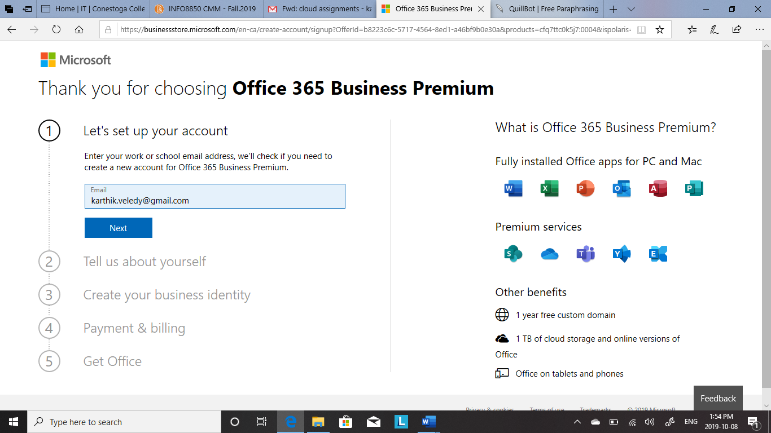

**Validation**: Validation is done in order to check whether registration is done successfully or not

Steps to validate ­­­­­­

1. Go to Microsoft Office login page
2. Enter the email address and password which is created at the time of registration

## **Add your domain (Global Admin)**

In the process of account setup, you should fill the details in Create your business identity section in order to you create your customized domain name or the default domain onmicrosoft.com. After choosing default or customized domain name add sub-domain to it.

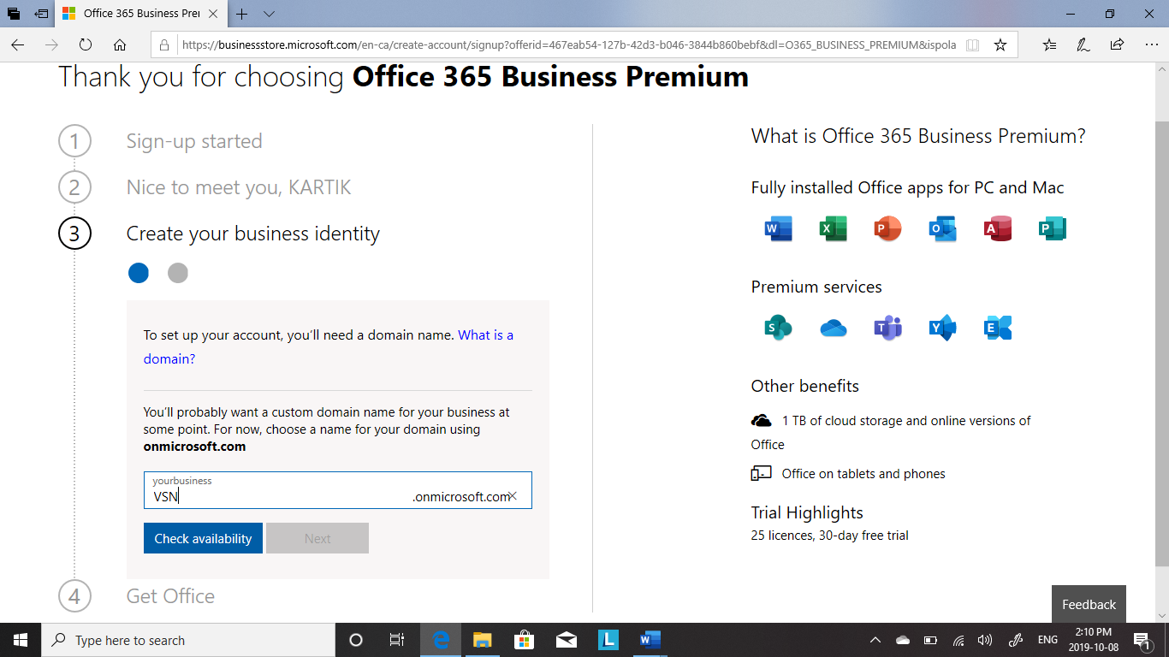

## **Validation:**

To verify if the domain is created or not. Simply go to profile after singing in and check for the domain name.

## **Add Your Users (Global Admin)**

Users can be added at the beginning or even after finishing the setup at admin page.

Add all the employees in the organization and create account for everyone.

1)By clicking on admin will redirect you to Microsoft 365 Admin center page

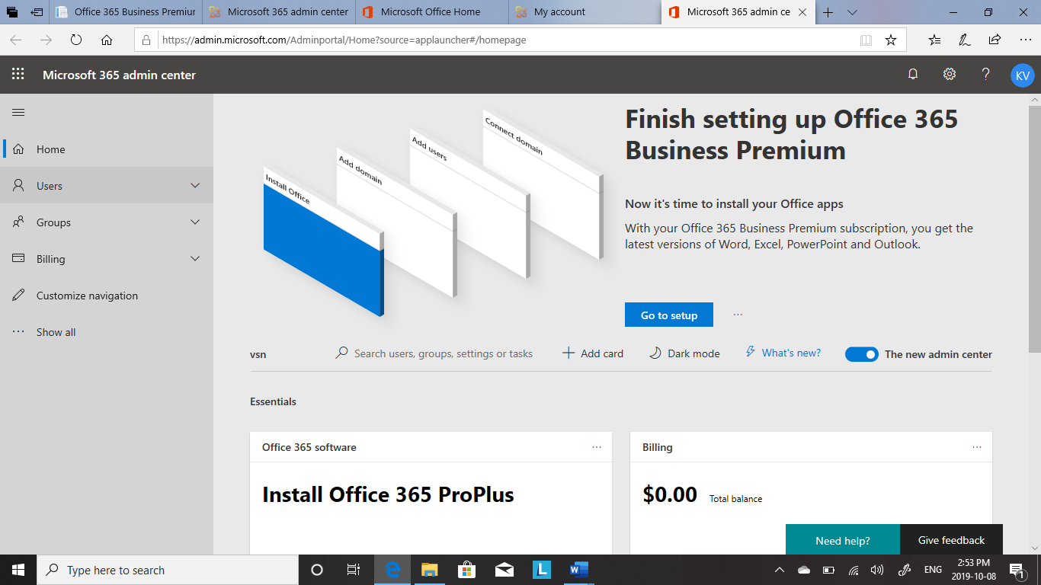

2)Click on Users

3) Click on active users

4) Click on add users

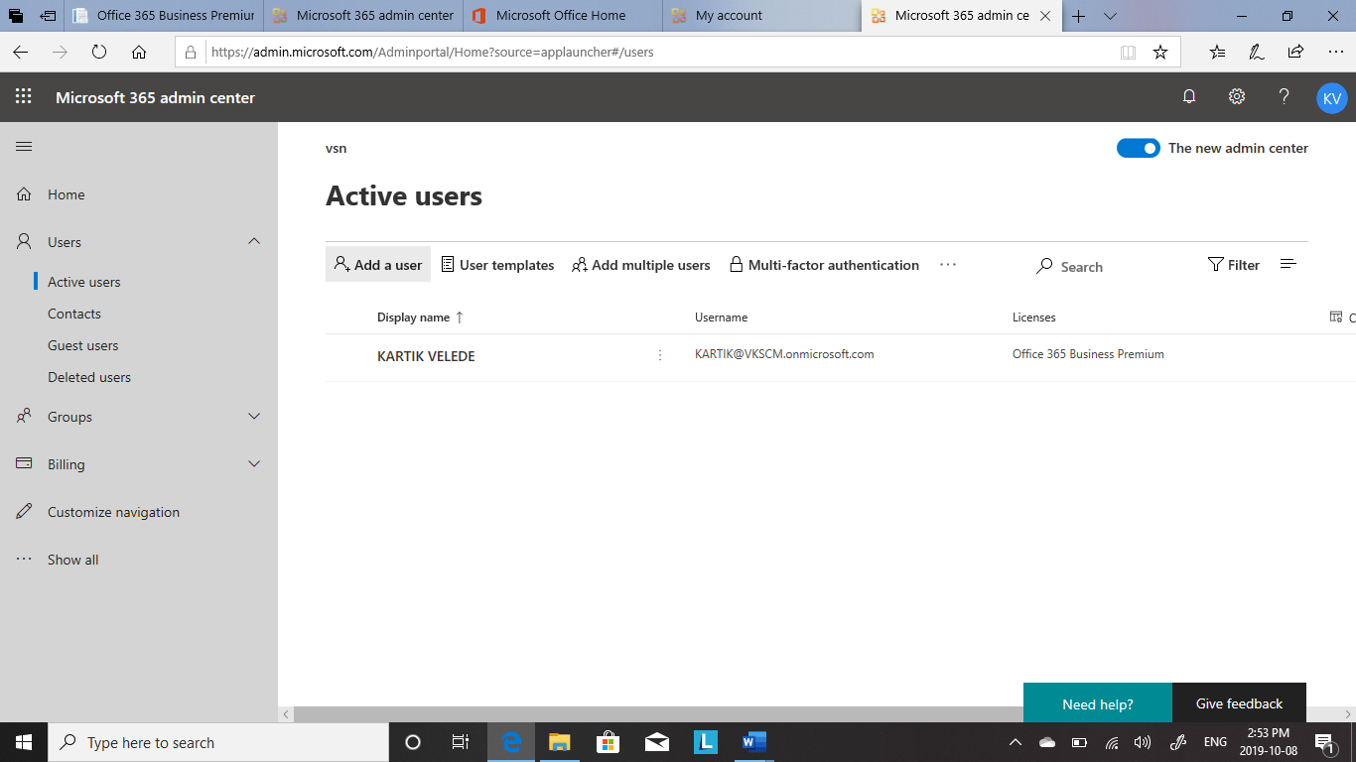

5)Fill out the basic information about who you are adding as a user

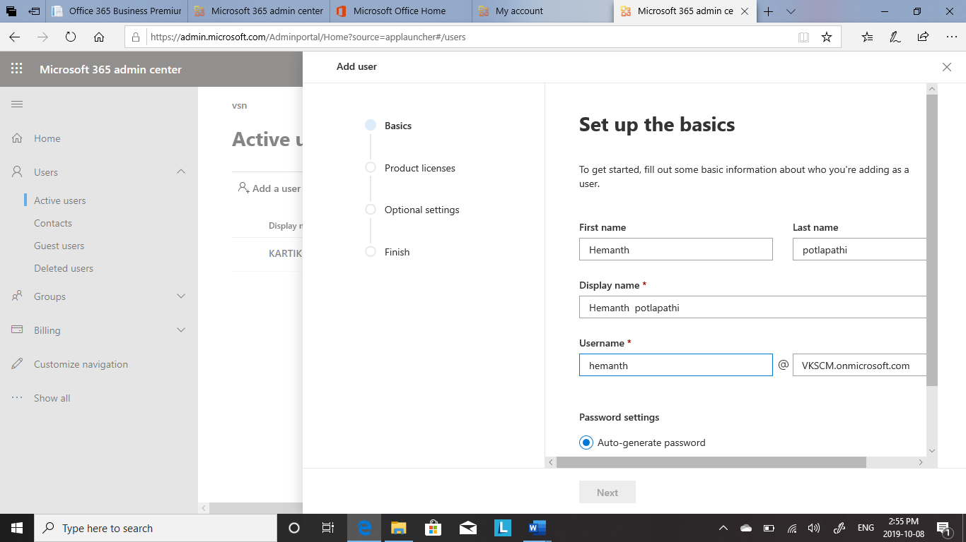

6)Assign user product license

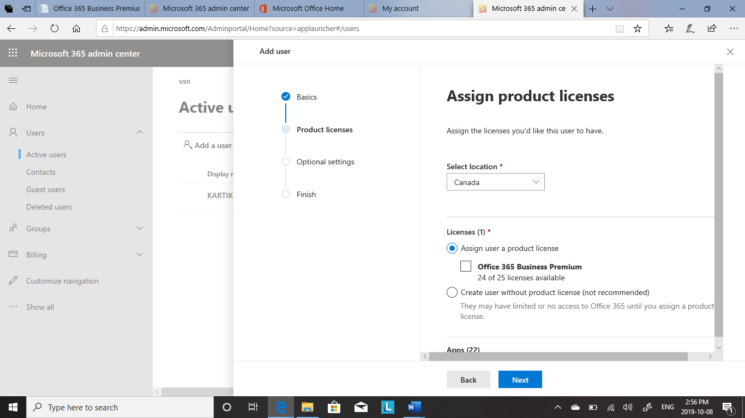

7)Click on finish

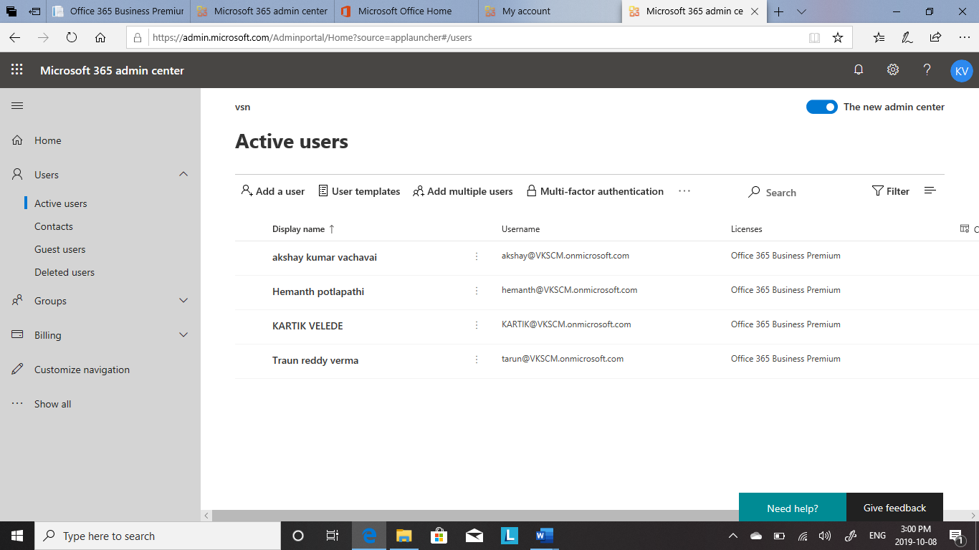

## **Validation:**

Stage 1: Following steps will help you confirm the successful addition of users

1. Login to account
2. Go to admin page center
3. Click on users and then active users

Then page will be displayed with all users added

Stage 2: Ask the employees to login in the Microsoft account by providing them with credentials such email address and password

## **Add groups (Global Admin)**

Every department in an organization should have a group

1. Go to group in the admin center page
2. Click on groups
3. Click on add groups

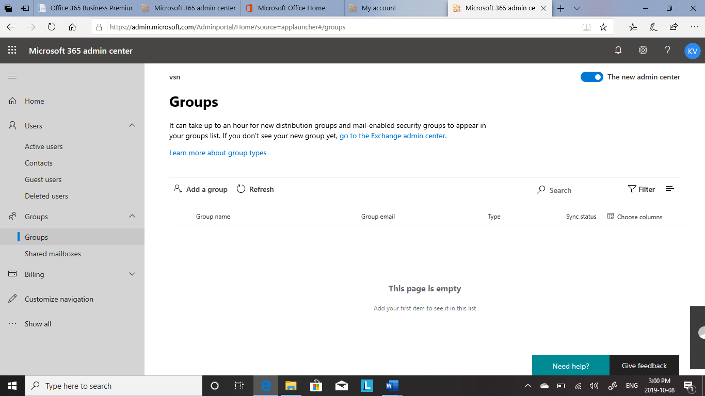

1. Fil out the basic information such as type , name and email address of the group

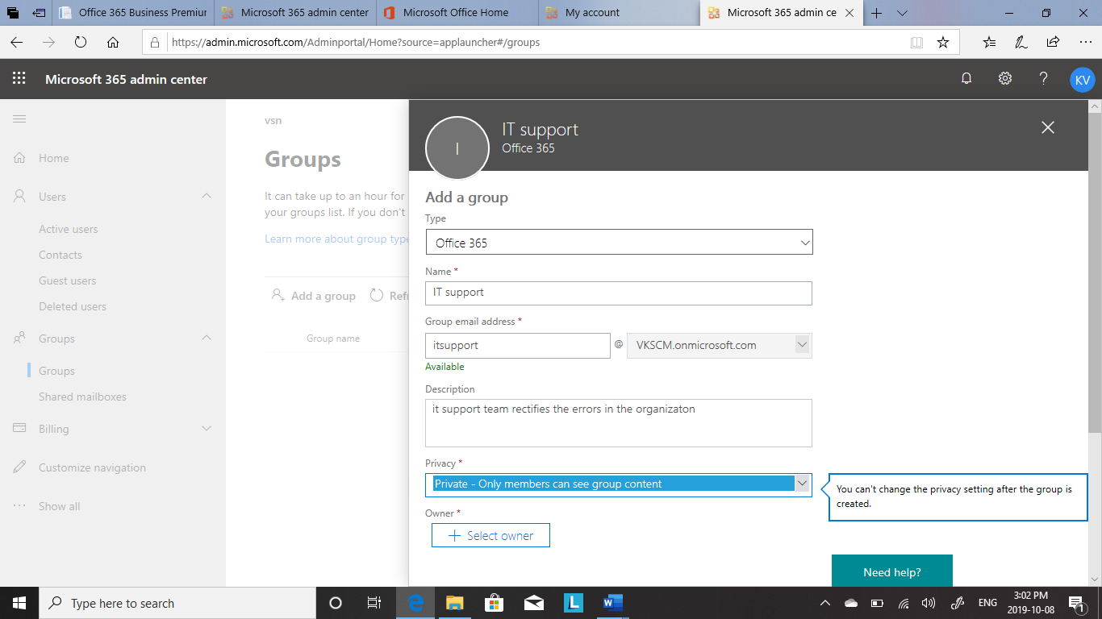

1. Click on add

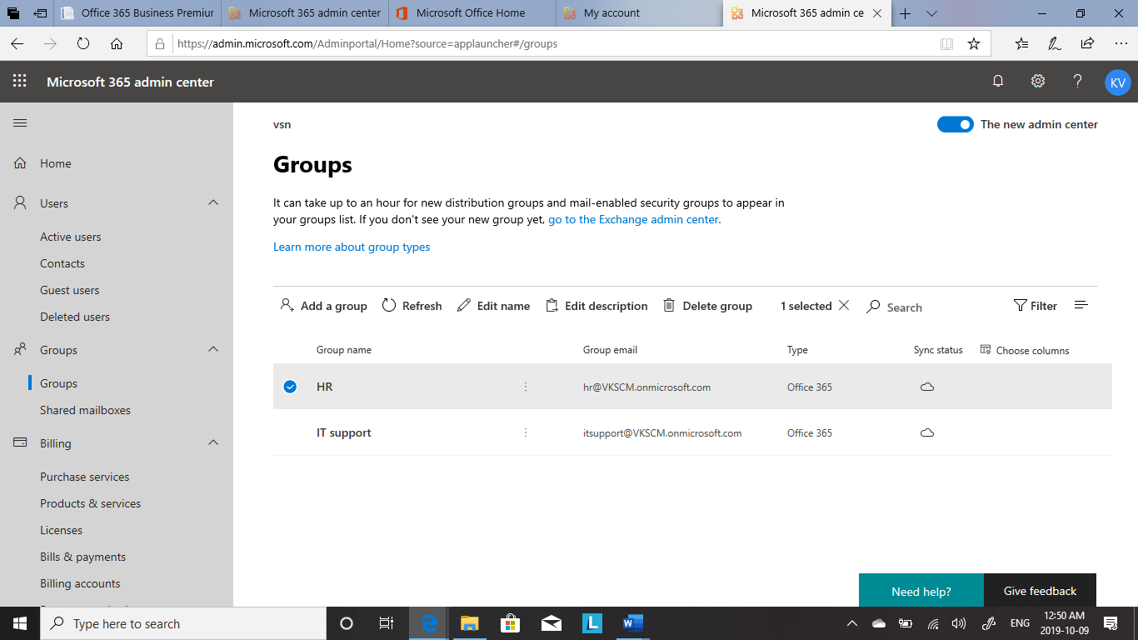

## **Validation:**

The following steps to be followed to verify the group creation

1. Login in the account
2. Go to admin center page
3. Select groups and click on groups

Here, you will get to see the groups of different departments or sections

## **Add users to group (Global Admin)**

Depending on the skills users should be assigned to groups

1. Click on the group where you the want user to be added
2. Select the user
3. Click on save

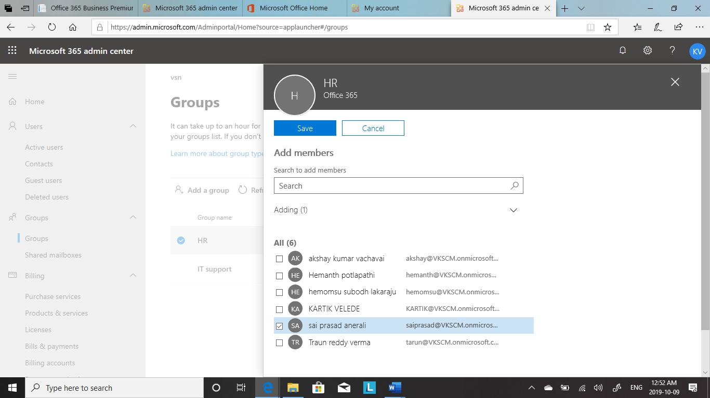

## **Assign roles to the user (Global Admin)**

Assign roles to the employees based on the designation, so that data can be accessed as per the requirements

1. Go to active users and click on users
2. Select the user for whom you want to assign the role
3. Go to user profile
4. Assign the role to user based on the skill set

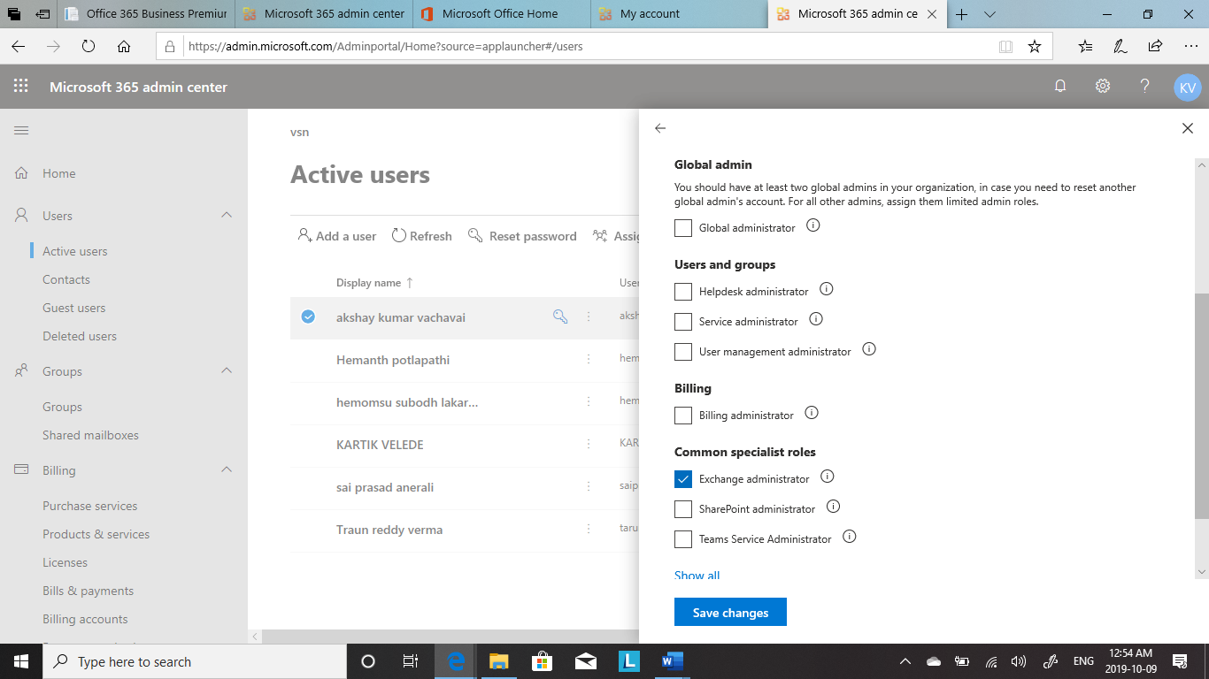

## **Install office apps (User)**

1)First login into Microsoft Office 365 account

2) Select install office and lick on install apps

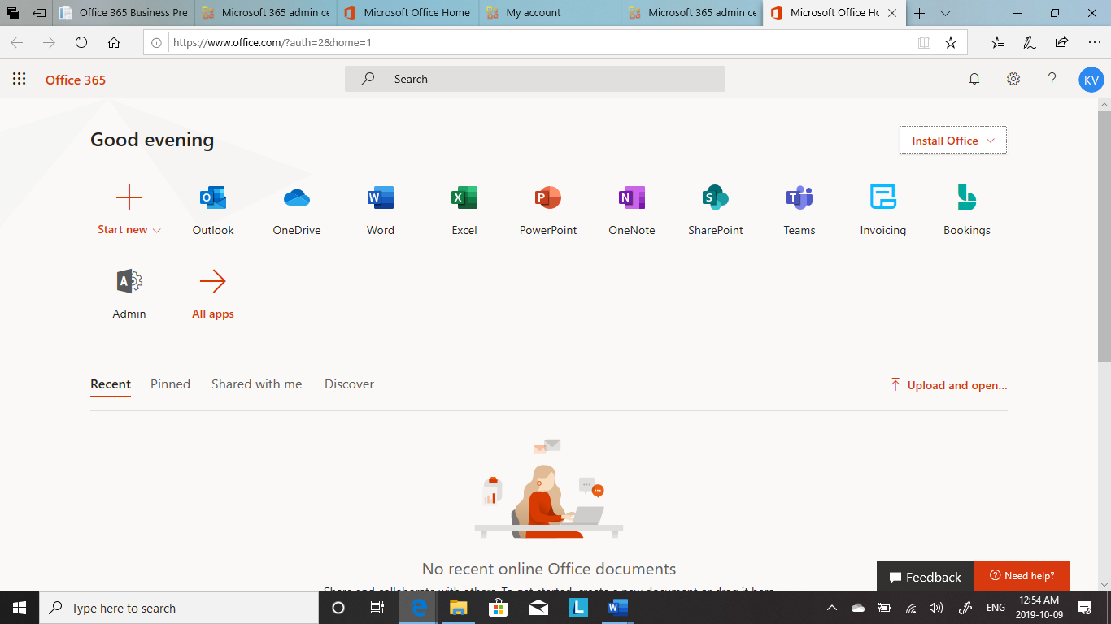

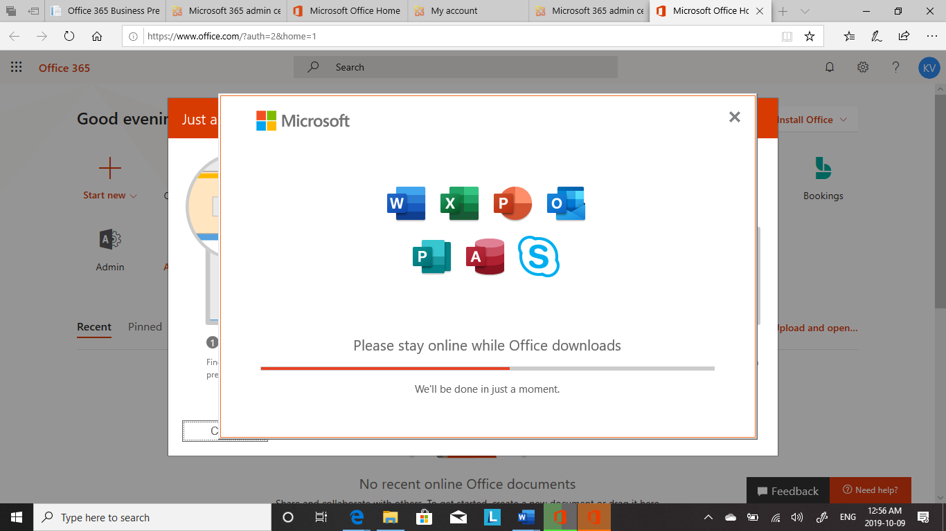

## **Outlook Configuration (User)**

1. Go to Microsoft account login up page
2. Login in the account
3. Click on outlook to configure

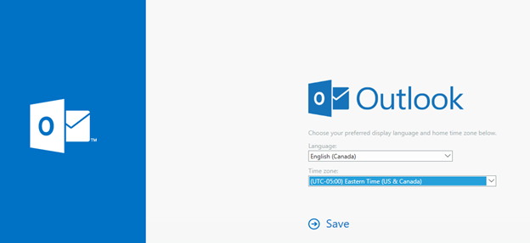

## **Email migration (Exchange admin)**

## **Data migration (SharePoint admin)**

# **GANTT CHART**

|  |  |  |  |  |
| --- | --- | --- | --- | --- |
| **Task Name** | **Responsible** | **Duration (Days)** | **Start Date** | **Finish Date** |
| Requirement gathering | Business analyst | 1 | 22-09-2019 | 23-09-2019 |
| Documentation of Requirements specification | Business analyst | 2 | 24-09-2019 | 26-09-2019 |
| Planning the Migration | Business analyst | 2 | 24-09-2019 | 26-09-2019 |
| Choose the service plan | Business analyst | 1 | 27-09-2019 | 28-09-2019 |
| Signup of the service | IT head (Global admin) | 1 | 02-10-2019 | 03-10-2019 |
| Validate the registration | IT head (Global admin) | 1 | 02-10-2020 | 03-10-2020 |
| Add your Domain | IT head (Global admin) | 1 | 02-10-2019 | 03-10-2019 |
| Validate the Domain | IT head (Global admin) | 1 | 02-10-2019 | 03-10-2020 |
| Add users | IT head (Global admin) | 1 | 03-10-2019 | 04-10-2019 |
| Validating the user creation | Employee of the organization(user) | 1 | 03-10-2019 | 04-10-2020 |
| Add groups | IT head (Global admin) | 1 | 03-10-2019 | 04-10-2020 |
| Add users to groups | IT head (Global admin) | 1 | 03-10-2019 | 04-10-2021 |
| Assign roles to users | IT head (Global admin) | 1 | 03-10-2019 | 04-10-2022 |
| Install apps | Employee of the organization(user) | 1 | 05-10-2019 | 06-10-2019 |
| Configure outlook | Employee of the organization(user) | 1 | 05-10-2019 | 06-10-2019 |
| Data Migration | SharePoint admin | 3 | 06-10-2019 | 09-10-2019 |
| Email Migration | Exchange admin | 3 | 06-10-2019 | 09-10-2019 |

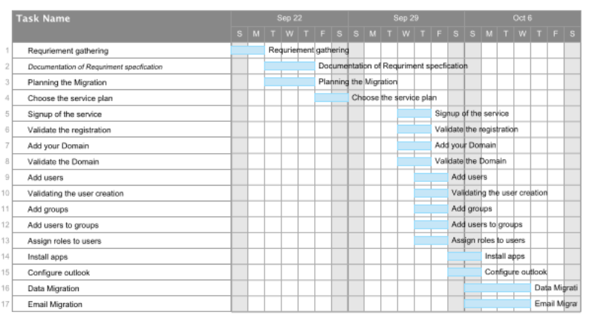

# **CITATIONS**

Microsoft. (2019). Get the most from office with office 365. Retrieved from  
        <https://products.office.com/en-ca>  
  
E-textbook- By  Matthew Katzer and Don Crawford  
          <https://link.springer.com/book/>